Data Center Waste Heat Offtaker Analysis:
EU Food & Beverage Manufacturing Sector

David Gardiner and Associates

Author: Priscilla Johnson, Ph.D.,
DOE Datacenter Energy Practitioner and HVAC Specialist

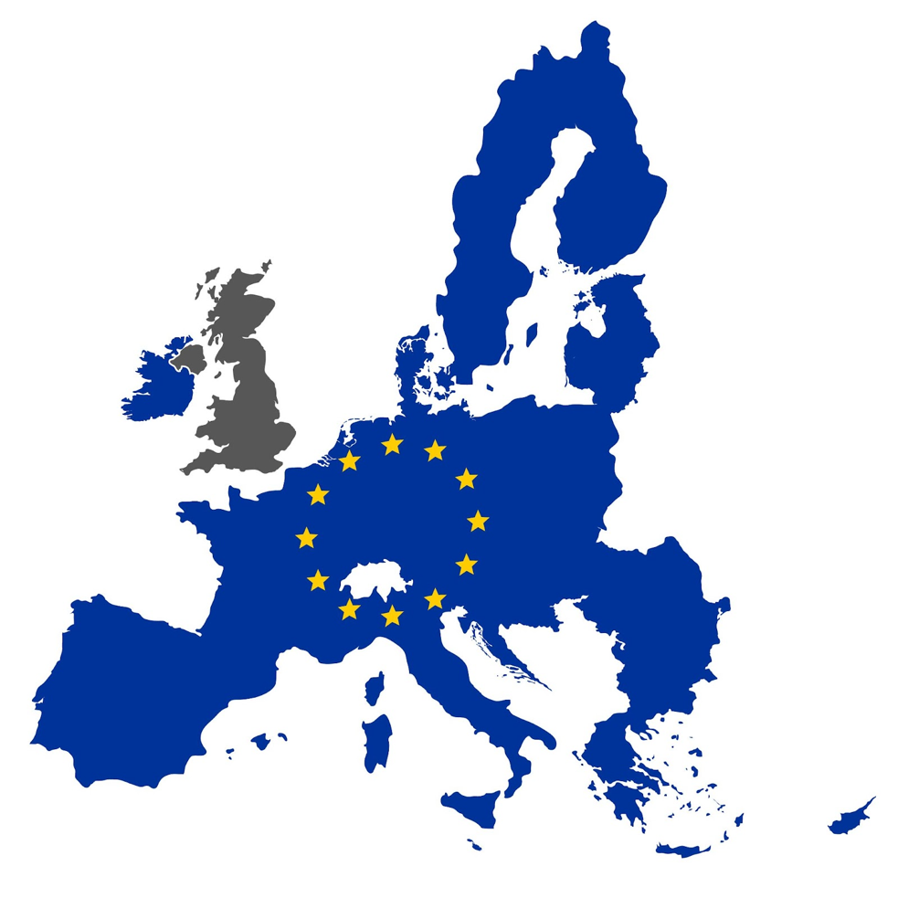

Table of Contents

Executive Summary 2
Key Findings 2
Market Opportunity Scale 2
Technical Compatibility 2
Partnership Readiness 3
Financial Considerations 3
Company Overviews 4
Company A Profile 5
Heat Needs 5
Financial Considerations 6
Compatibility 6
Company B Profile 7
Heat Needs 7
Financial Considerations 7
Company C Profile 9
Heat Needs 9
Compatibility 9
Financial Considerations 10
Company D Profile 11
Heat Needs 11
Compatibility 11
Financial Considerations 12
Company E Profile 13
Heat Needs 13
Compatibility 13
Financial Considerations 14
Company F Profile 15
Heat Needs 15
Compatibility 15
Company G Profile 17
Heat Needs 17
Financial Considerations 17
Compatibility 18
Recommendations 19
Conclusion 20

Executive Summary
This report presents a feasibility analysis as a result of expert interviews with seven major food and beverage manufacturers who may be potential data center waste heat offtakers at Microsoft’s European data centers. The project goal is to understand where opportunities exist for this technology application and to evaluate some of the key needs and obstacles for potential waste heat offtakers.
Interviews took place from July to September 2025 and included sustainability and technical leaders from companies that represent more than $450B in revenue, 135 facilities across the European Union, and temperature applications ranging from 30-350°C. Each interview lasted approximately one hour using Microsoft Teams with the guideline that David Gardiner & Associates (DGA) would maintain the confidentiality of their identity and anonymity of their data.

Key Findings
Key findings are presented in the context of four main themes: market opportunity scale, technical compatibility, partnership readiness, and financial models.

Market Opportunity Scale
The companies represent a spectrum from small-scale distributed partnerships (a company with six European facilities with 1,000-100,000 GJ annual demand) to industrial-scale opportunities (a company consuming up to 300 MW thermal load). Combined, these partners offer sufficient scale to absorb waste heat from multiple large data centers while providing geographic distribution across key European markets.

Technical Compatibility
Data center waste heat (typically at 30-50°C when leaving the data center) shows strong compatibility with industrial applications through heat pump integration. The temperature of data center waste heat is well-suited for the lower-temperature heat needs at food & beverage facilities, such as cleaning and process heat, with at least five companies noting high compatibility with their lower temperature heat needs (i.e. 60-90°C). Company D and Company G have established heat pump infrastructure ready for integration, with at least three other companies noting heat pumps at their existing facilities. All companies operate primarily 24/7, ensuring consistent heat demand matching data center output profiles.
In the Net-Zero-Emissions scenario developed by the International Energy Agency, heat pumps will supply 30% of the heat demand at low to medium temperature levels in light industries, especially the "food, beverages, and tobacco" industry, by 2050. The food and beverage segment holds the largest market share in industrial heat pumps, accounting for approximately 37.5% of the global market in 2023, with demand driven by the need for efficient heating solutions in processes such as pasteurization, drying, and fermentation.

Partnership Readiness
Interviewees consistently expressed enthusiasm and were universally intrigued by the idea of utilizing data center waste heat. All interviewed companies have ambitious climate targets and an interest in seeking out innovative climate solutions—and many also noted that they have exhausted the “low-hanging fruit” to decarbonize their facilities and are ready for new ideas.
The companies largely fall into the following partnership archetypes with varying strengths and weaknesses as per Microsoft’s current strategy shared with DGA:
- Experienced implementation partner - two proven external waste heat projects
- Distributed opportunity partner - preferring utility-as-a-service models across multiple smaller facilities
- Technical integration specialist with active heat pump deployment projects
- Scale partnership - leader offering largest thermal demand and innovation focus
- Established industrial partner - has complex requirements but stable long-term demand
- Agile pilot partner - suitable for rapid proof-of-concept demonstrations

These partnership characteristics are explored in more depth in the Company Profiles, below.

Financial Considerations
Investment approaches vary significantly, from conservative 3-year payback requirements from two leading consumer brand companies to 15-20 year project horizons for a major drink and snacks manufacturer. Notably, a company’s preference for utility-as-a-service models creates opportunities for heat-as-a-service revenue streams, while another uses climate metrics like cost per ton of CO₂ reduced to enable precise sustainability value quantification.
All companies demonstrate strong alignment with data center waste heat utilization for decarbonization goals. Two show the most aggressive internal targets exceeding regulatory requirements, while another company faces challenging sustainability timelines that make waste heat partnerships particularly valuable. Multiple companies noted that while they prefer shorter payback periods (two to three years), this is not a strict requirement if the project can provide other benefits such as carbon reduction, innovative pilot successes, or beneficial partnerships.

Company Overviews
The food and beverage companies interviewed as potential data center waste heat offtakers operate 135 facilities across the European Union with temperature applications ranging from 30-350°C.
This report evaluates seven companies for operational compatibility, heat demands, and partnership readiness for collaboration with Microsoft’s current data center portfolio. Table 1 presents a summary of their temperature needs, location, and ranking by scale of opportunity for Microsoft’s increasing potential as a waste heat supplier.
Table 1. Company Overview
Company | Temperature Needs | Heat Range Demand | Geographic Spread | Scale of Opportunity
Company A | 60-100 deg C for most processes; 80-120 deg C for some higher temperature food processes | 1.2 TWh/year | 30-35 facilities throughout the EU | 1
Company B | 93-149 deg C | Up to 300 MW thermal load | Netherlands, Germany, France, Italy, Spain | 2
Company C | 60 deg C for pet food;  90 deg C for human food;  180 deg C for drying | 426,000 GJ/year | Germany (7), France (4), Netherlands (1), Italy (1) | 3
Company D | 90 deg C for beverage steam pasteurization;  200 deg C for frying | 18-24 MW per facility | Portugal, Spain, Belgium, Poland, UK | 4
Company E | 80-90 deg C for process heat;  150 deg C for frying;  150-175 deg C for steaming | Moderate industrial scale | France, UK | 5
Company F | 60-80 deg C for low heat;  150-200 deg C for high heat | 1,000-100,000 GJ per site | Geneva, Zurich, Netherlands, Spain, Italy, UK, Germany | 6
Company G | 60-100 deg C | 30-60 million kWh of natural gas | Sweden, Netherlands | 7
The remainder of this section provides a detailed analysis of each company’s heat needs and compatibility with Microsoft as a potential data center waste heat partner.

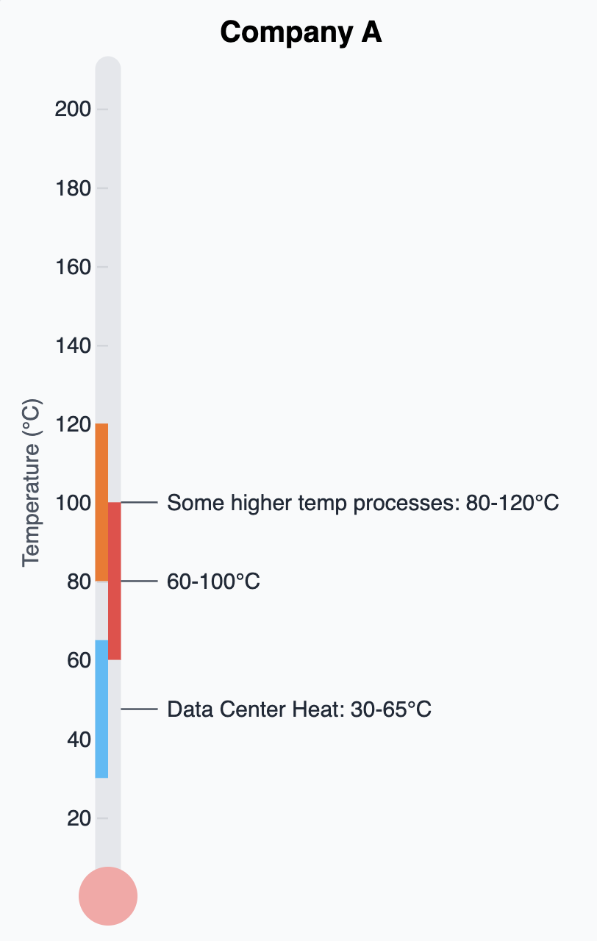
Company A Profile
Company A provides significant opportunity by offering both the largest scale and lowest implementation risk among food and beverage manufacturers in the European market. Operating 35 facilities across Europe with a massive 1.2 TWh annual thermal demand representing 60% of their total energy consumption, Company A demonstrates exceptional scale. This scale aligns with projections that recoverable waste heat from data centers could reach 3.5 TWh by 2030, making them an optimal partner for significant waste heat utilization.
Their diversified operations span specialized nutrition requiring high-temperature milk drying processes, a waters division managing beverage and mineral water production, traditional dairy processing, and plant-based alternative dairy products, creating multiple partnership entry points with varied heat demand profiles suitable for pilot testing and scaling initiatives.

Heat Needs
Company A's temperature requirements fall within the optimal 60-100°C range for data center waste heat integration, with primary processes including beverage preparation, pasteurization, and cleaning applications that align perfectly with data center waste heat temperatures of 25-35°C for air-cooled systems and 50-60°C for water-cooled systems, enhanced through heat pump technology that can achieve temperatures up to 120°C. High-temperature heat pumps can be critical in boosting data center waste heat for industrial applications, improving system-level energy efficiency and reducing CO₂ emissions. Their existing heat pump implementation across facilities demonstrates advanced technical readiness, with operational experience in thermal system transitions including steam to hot water conversions and comprehensive waste heat recovery systems within their manufacturing operations.

Financial Considerations
The company prefers to achieve a return on investment (ROI) within three years but noted that timelines could be flexible if the project has a significant climate impact, reflecting its aggressive commitment to sustainability, including a Science-Based Targets initiative (SBTi) pursuit. Company A explicitly states that "space constraints are not a concern" for data center heat integration infrastructure, eliminating a common implementation barrier identified across other food processing partners. Their innovation-focused culture emphasizes pilot testing capabilities and active engagement with new suppliers, supported by dedicated teams that enable rapid evaluation and deployment of emerging thermal technologies.

Compatibility
Company A's strategic facility location approach positions dairy and specialized nutrition facilities near agricultural sources while water and beverage operations locate near water sources, with consideration factors including proximity to renewable energy, biomass feedstocks, and availability of government programs like subsidies.
Industrial heat pumps can amplify temperatures to 60°C or higher, while multi-stage heat pumps can achieve temperature values of 150°C or higher, supporting Company A's diverse temperature requirements across their facility portfolio. Their expansion strategy focuses on enhancing existing facilities rather than new construction, creating opportunities for retrofitting data center waste heat systems into proven operational environments.
The company's implementation timeline spans 6-12 months, accelerated by their pilot testing capabilities and existing thermal infrastructure. However, challenges include:
- demand variability due to production line interruptions requiring flexible heat supply systems,
- geographic distribution across 35 facilities complicating initial partnership focus, and
- integration complexity for factory-wide thermal system modifications to maximize benefits.
Company A's commitment that they are "running out of low hanging fruit" indicates exceptional motivation for innovative solutions, positioning them as the most advanced partner among analyzed manufacturers for large-scale data center waste heat integration with immediate business impact potential.

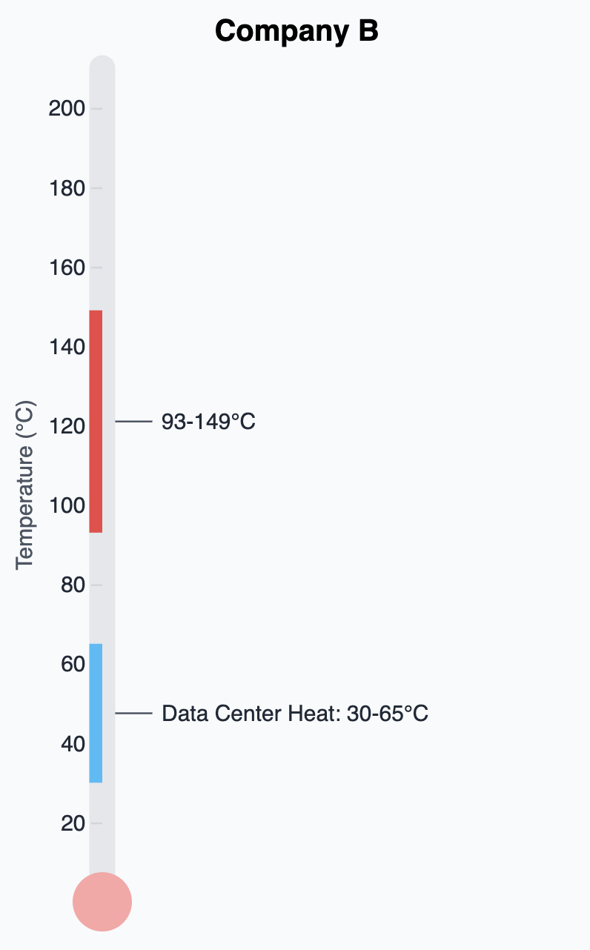
Company B Profile

Heat Needs
Company B operates as a specialized industrial processor focusing on drying and oil seed processing applications, requiring consistent thermal energy within an average temperature range of 200°F to 300°F (93°C to 149°C). This temperature requirement positions the company favorably for data center waste heat integration, particularly when enhanced through heat pump technologies that can amplify low-grade data center heat to industrial-grade temperatures.
The company's existing infrastructure already incorporates heat recovery systems throughout their manufacturing facilities. However, they are currently investigating the integration of heat pumps to further optimize their energy utilization strategy. The viability of utilizing high-temperature multi-stage heat pumps as presented in a case study to boost data center waste heat for industrial applications indicates that configurations of two-stage cycles with an internal heat exchanger, a flash tank and internal heat exchanger, and economizer/parallel-compressor provide the highest coefficient of performance. A one MW high-temperature heat pump will reduce 33,100–33,200 metric tons of CO₂ emissions annually, corresponding to 85.4%–85.6% of equivalent CO₂ emissions from natural gas boilers.
This company's data center heat compatibility assessment reveals a "good" potential for integration using heat pump technologies.

Financial Considerations
From a financial evaluation perspective, Company B has not yet determined a specific ROI timeframe for data center waste heat integration projects. Their approach follows traditional corporate finance methodologies, utilizing Internal Rate of Return (IRR) and Net Present Value (NPV) analysis frameworks once target partnerships are identified. This will be complemented by conventional capital expenditure financial modeling to assess project viability and investment returns.
The interview process revealed Company B's high operational flexibility and rapid project evaluation capabilities when working with potential waste heat partners. This agility represents a significant advantage in the evolving data center waste heat market, where enhanced modular data center solutions with integrated heat capture systems are accelerating implementation timelines. The company currently categorizes their implementation complexity as medium, indicating manageable technical and logistical barriers to deployment.
Company B's facility location strategy prioritizes proximity to large industrial zones, with logistics infrastructure and waterway access serving as primary site selection drivers. This geographic positioning often coincides with data center development patterns, as both industries require robust utility infrastructure, transportation access, and industrial zoning compatibility.
The company operates without formal sustainability targets in renewable energy adoption or net zero commitments, focusing instead on operational efficiency and traditional business metrics. However, their active exploration of external heat offtake opportunities and existing heat recovery infrastructure demonstrate practical environmental stewardship through energy optimization rather than mandate-driven sustainability programs.

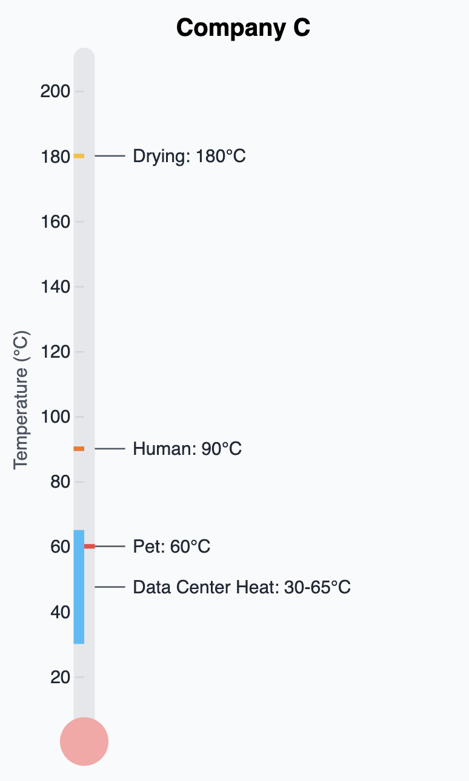
Company C Profile
Company C operates as a major food processing manufacturer specializing in both human food and pet food production across multiple European facilities, with complex thermal energy requirements.

Heat Needs
Company C’s wet pet food production and processing require substantial volumes of 60°C water, while their dry pet food manufacturing operations demand the highest temperatures ranging between 150-180°C for drying processes, which remain among the most challenging to decarbonize within the food processing sector.

Compatibility
As of September 2025, Company C maintains limited experience with heat pump technologies across their European manufacturing portfolio, though they have one system currently in pre-commissioning stage at their North American facility. The company's European operations are actively investigating heat pump integration, particularly as waste heat sources for feeding these systems, with their Switzerland factory already implementing hot water heat pump systems.
Their data center waste heat compatibility assessment reveals moderate potential, primarily constrained by food safety quality concerns rather than technical temperature matching limitations. Company C's core processes involve direct contact with food products, creating stringent requirements for intermediate heat exchangers and secondary barrier systems to prevent contamination. The proposed waste heat recovery plan entails capturing heat at 28°C, harnessing 6.6 MW generated from the data center's cooling process through the utilization of heat pumps, which could theoretically meet Company C's lower-temperature requirements when enhanced through heat pump amplification. However, their concerns center on maintaining the sterility and quality standards essential for food production, particularly given that sterilization processes are critical for human food manufacturing where temperatures of 180-190°F are required to eliminate bacteria.

Financial Considerations
The company maintains a strict three-year return on investment requirement for capital expenditure projects using traditional financing models. However, interview discussions revealed a unique perspective regarding data center waste heat partnerships: Company C believes Microsoft should supply waste heat at no cost, arguing that data centers benefit more from having reliable offtakers than food processors benefit from receiving the heat. This position reflects their view that waste heat represents a disposal solution for data center operators rather than a premium energy product.
The interview revealed limited operational flexibility for integrating external waste heat sources, though the company expressed strong curiosity about learning more regarding implementation opportunities. High-temperature heat pump technology is gradually emerging as a key driver for transformation and upgrading within the food processing industry, suggesting growing industry momentum that could influence Company C's future adoption decisions.
Company C's facility location strategy prioritizes remote industrial zones due to operational odors associated with pet food manufacturing processes and the significantly higher infrastructure costs required for odor management systems when operating near population centers. This geographical positioning often creates logistical challenges for data center waste heat integration, as data centers typically locate near population centers for connectivity and skilled workforce access.
The company's approval processes for waste heat integration projects would involve complex internal evaluations and potentially extensive infrastructure modifications. All facilities maintain decarbonization commitments aligned with European sustainability mandates, though their assessment indicates limited immediate opportunities for data center waste heat integration given current technical constraints and quality requirements inherent in food processing operations.

Company D Profile

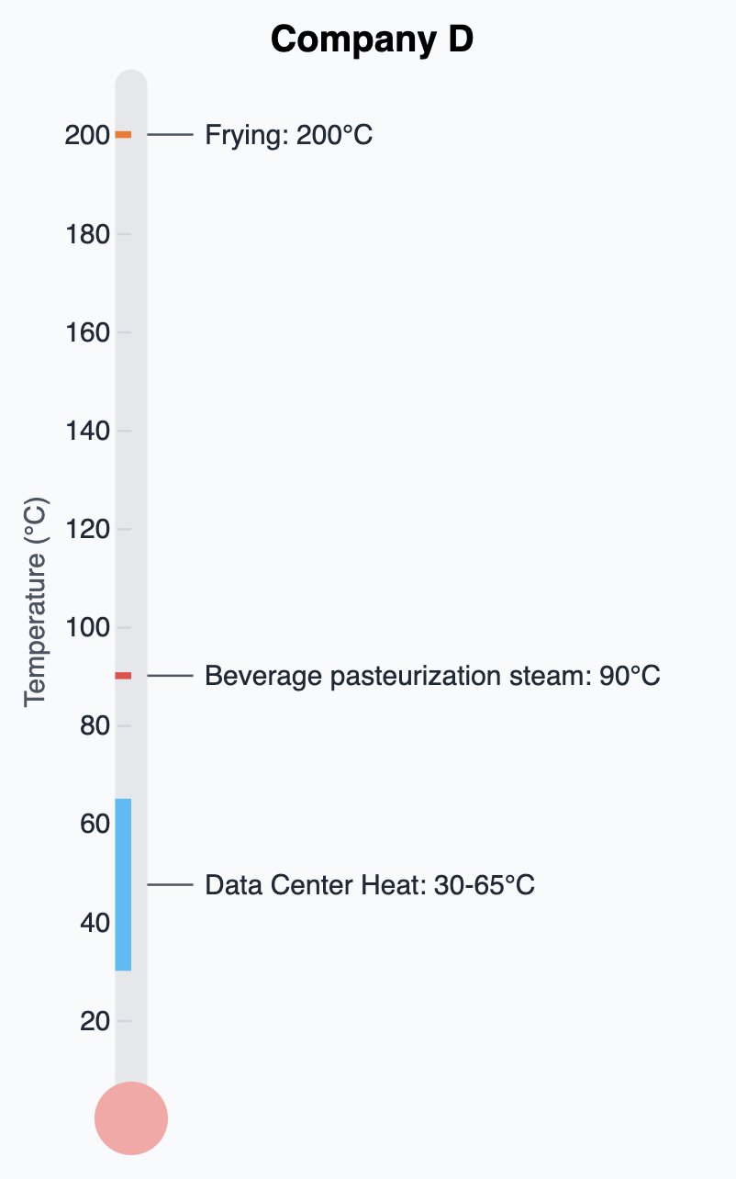
Heat Needs
Company D is a sophisticated food and beverage manufacturer operating dual production streams with distinctly different thermal requirements spanning from high-temperature frying operations demanding approximately 200°C for snack manufacturing to moderate-temperature pasteurization processes requiring 90°C for beverage sterilization. Frying is the most challenging of their operations to decarbonize, utilizing thermal energy to heat cooking oil within medium-temperature ranges, while their beverage pasteurization processes involve heating products above 70°C for pasteurization, typically below 100°C, to inhibit phase changes and control acidity parameters.

Compatibility
Their potential for heat pump integration is considered excellent, positioning them as an industry leader in thermal energy optimization strategies. As of 2025, Company D is in the process of deploying heat pump projects across multiple European facilities including Belgium, Spain, Poland, and the UK, with particular focus on their Belgian facility near Veurne where heat pump integration is already under evaluation. The company demonstrates sophisticated understanding of heat pump technology applications, recognizing that data center waste heat at typical temperatures of 25-35°C for air-cooled systems and 50-60°C for water-cooled systems represents a "decent" temperature range for lifting through their existing heat recovery systems and integration with heat pump amplification.
Company D exhibits exceptionally high readiness as a data center waste heat offtaker. Their facilities already incorporate heat recovery systems that could be coupled with data center output, creating synergistic energy utilization where external heat sources reduce the workload required from their heat pump systems. About 97% of the heat required for food and beverage processing is below 130°C, commonly used for pasteurization, cleaning and drying, aligning well with enhanced data center waste heat capabilities through heat pump amplification.

Financial Considerations
The company's return on investment framework of 15-20 years for heat pump and thermal efficiency projects places them significantly ahead of traditional capital expense financing models, demonstrating long-term strategic thinking rather than short-term payback requirements. This extended ROI timeline reflects their commitment to sustainable infrastructure investments, with dedicated funding already allocated for heat pump initiatives that represent "step change in performance" improvements. Their Belgium facility project, requiring up to 6 MW of heat capacity with substantial capital expenditure, exemplifies their willingness to pursue medium-heat decarbonization solutions even when traditional cost-saving opportunities are limited.
With an engineering-led implementation team, Company D expressed a willingness to engage with Microsoft on data center heat reuse projects. The company expresses particular interest in understanding data center output specifications including flow rates, temperature profiles, availability patterns, and water quality characteristics to inform integration planning.
Company D demonstrates exceptional sustainability commitment through active heat pump deployment and sophisticated thermal integration capabilities. Their facility location strategy prioritizes market proximity, focusing on customer accessibility and agricultural supply chain optimization, though they indicate data center waste heat availability could serve as a secondary site selection criterion when choosing between comparable locations.

Company E Profile

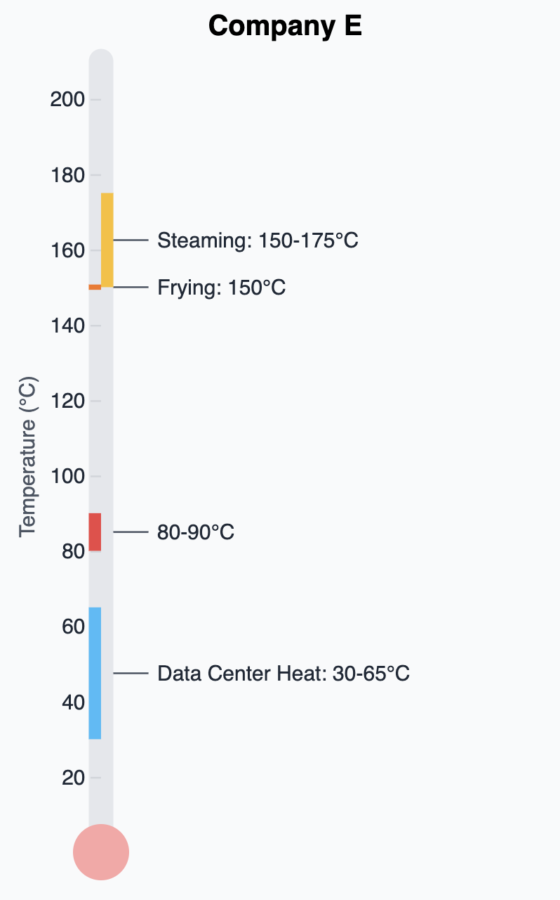
Heat Needs
Company E is a proven leader in heat offtake, operating extensive confectionery and pet food manufacturing operations requiring comprehensive thermal energy management for process water, wash-down applications, and sterilization processes within an average temperature range of 80-90°C. Current heat pump technologies are mostly limited to heat supplies of 70–80°C, while heat demand temperature in many industrial processes is significantly higher, positioning Company E's temperature requirements at the optimal convergence point for data center waste heat integration. The company's candy production operations utilize 80-90°C heated process water to ensure product liquidity during processing, while their pet food division requires high-temperature steam environments of 150-175°C for canned food sterilization, demonstrating sophisticated multi-temperature thermal management capabilities.

Compatibility
Their data center waste heat offtaker compatibility is classified as excellent, particularly given their proven operational heat pump systems and existing waste heat recovery infrastructure. About 97% of the heat required for food and beverage processing is below 130°C, and is commonly used for pasteurization, cleaning and drying, aligning perfectly with enhanced data center waste heat through heat pump amplification. Company E's engineering team recognizes that data center cooling water temperatures typically range from 23-25°C in the return flow, providing waste heat potential at maximum 25°C water temperature, which can be effectively integrated into their existing thermal loops where 50°C supplemental water reduces energy requirements for reaching their target 90°C process temperatures.

Financial Considerations
The company maintains stringent financial criteria with standard ROI requirements limited to a 3-year maximum payback period for capital investments, though this framework demonstrates flexibility when primary objectives include decarbonization alongside economic returns. Their evaluation methodology prioritizes cost per ton of carbon reduced, enabling comprehensive assessment of environmental and economic benefits. Notably, Company E exhibits strong preference for long-term contractual commitments spanning 10-15 years, reflecting their understanding that substantial thermal infrastructure investments require extended operational timeframes to achieve optimal returns. This long-term perspective has proven successful through their existing heat offtaker implementations, which have operated reliably for over a decade.
Following comprehensive technical and economic evaluations, Company E has successfully implemented two external heat offtaker projects despite operating within exceptionally tight factory floor space constraints, positioning them as a low-risk partner among potential data center waste heat offtakers. Their French facility maintains an operational agreement with a neighboring waste steam producer utilizing direct piping and heat exchanger systems, while their Slough facility receives 90% of thermal requirements from an adjacent utility power generation station, demonstrating exceptional operational reliability and risk management.
Company E's site selection criteria encompass varied strategic considerations, though proven external thermal connections are a mandatory prerequisite before committing to heat offtaker partnerships. Their existing implementations demonstrate sophisticated understanding of infrastructure requirements, regulatory compliance, and operational reliability standards essential for successful data center waste heat integration.
Company E maintains well-defined sustainability targets with aggressive decarbonization commitments including 100% renewable energy by 2040 for both Scope 1 and 2 emissions, complemented by comprehensive net zero commitment encompassing 90% of their entire value chain by 2050.

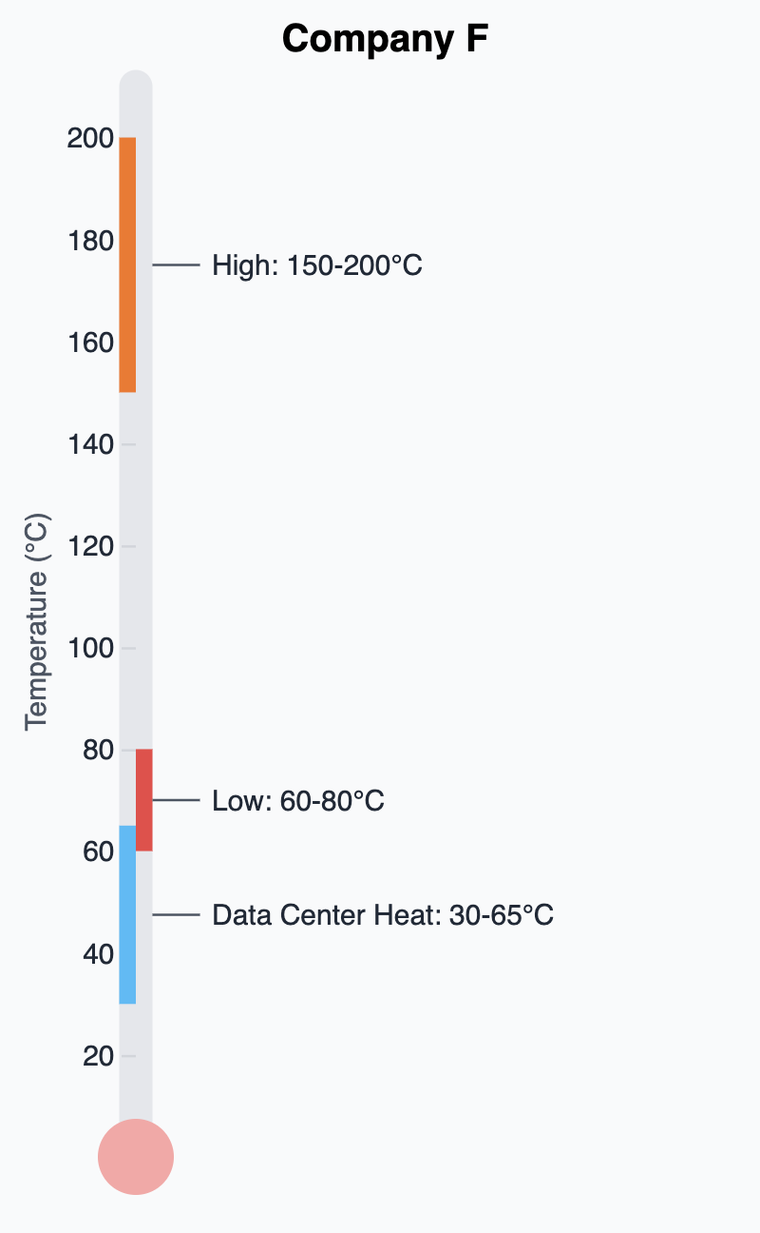
Company F Profile
Company F represents a specialty chemicals and fragrances corporation operating 85 facilities globally with six European locations including Geneva, Naarden near Amsterdam, Catalonia, Milan, Ashford UK, and Dortmund, Germany. It offers smaller-scale data center waste heat opportunities with distinctive business model preferences centered around utility-as-a-service relationships. Data centers operate 24/7 with high operational safety requirements and generate continuous low-grade waste heat, matching Company F's need for consistent thermal energy across their manufacturing operations where some facilities require continuous 24/7 heat while others operate more intermittently based on production schedules.

Heat Needs
The company's primary heat applications encompass equipment cleaning requiring 60-80°C and high-temperature steam processes demanding 150-200°C, creating dual thermal requirements that position them strategically for data center waste heat integration. Industrial heat pumps with supply temperatures of up to 100°C can efficiently boost data center waste heat for various applications, showing promise to improve system-level efficiency, aligning perfectly with Company F's heat pump integration strategy targeting 20-50°C input temperatures for equipment cleaning applications. Their facility location strategy prioritizes customer proximity while avoiding residential areas due to fragrance manufacturing odors, typically positioning them in industrial zones where data center co-location becomes more feasible from regulatory and zoning perspectives.

Compatibility
Company F demonstrates exceptional readiness as a data center waste heat partner through their systematic approach to thermal management. They have developed site-by-site decarbonization roadmaps incorporating multiple energy source integrations including natural gas, geothermal, solar thermal, and biomass systems, with specific heat pump implementation planning targeting data center-compatible input temperature ranges. The company noted that, in newer facilities, it was building in the capacity for heat recovery for its own facility, and it is planning retrofits to some older sites. Energy networks operating at 25°C temperatures could accommodate waste heat from air-cooled data centers directly, though Company F's requirements typically necessitate heat pump amplification to reach their 70-90°C processing temperatures.
While Company F lacks external heat offtaker experience, they compensate through aggressive internal sustainability targets exceeding regulatory requirements with 90% carbon emission reduction commitments by 2045. Their decision-making framework prioritizes sustainability initiatives with medium to low implementation complexity, supported by dedicated sustainability operations governance structures including steering committees and specialized workstreams for renewable energy, waste management, and thermal optimization. The company's acquisition-driven growth strategy, exemplified by a 2018 acquisition adding 15 facilities, creates multiple potential co-location opportunities for data center partnerships across varied geographic markets.
Company F's thermal energy demands range from 1,000 to 100,000 gigajoules annually per facility, enabling scalable pilot program development and phased implementation approaches. Data center waste heat recovery can increase overall profitability while reducing electricity usage and improving carbon emissions, supporting Company F's economic and environmental objectives. Their utility-as-a-service business model preference, demonstrated through existing biomass boiler partnerships with 10-15 year commitments where partners build and operate equipment while Company F pays per unit consumed with eventual equipment ownership transfer, provides an established framework for data center waste heat infrastructure development.
This proven utility-as-a-service approach eliminates capital expenditure barriers while enabling Company F to focus resources on core chemical and fragrance manufacturing competencies rather than thermal infrastructure management. Their experience with biomass sourcing partnerships, where they acknowledge lacking internal expertise and rely on specialized partners for equipment installation and operation, creates precedent for similar data center waste heat collaboration models. With moderate heat needs across multiple smaller facilities and strong sustainability focus, Company F offers exceptional long-term partnership potential with willingness to finance innovative thermal solutions through established service-based business relationships.

Company G Profile

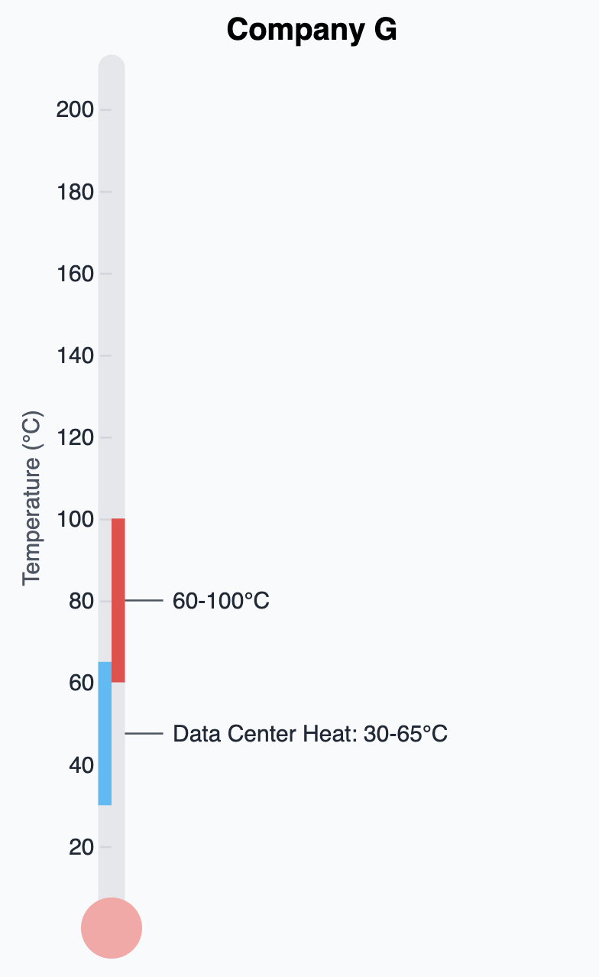
Heat Needs
Company G operates specialized oat processing facilities in Sweden and the Netherlands, representing a small to medium-scale manufacturing operation that utilizes heat for grain processing at temperatures ranging from 194-284°F (90-140°C) with exceptional heat pump integration readiness. Oat groats (when processed with superheated steam to a final moisture content of 9-10% wet basis) require processing temperatures of 110°C, aligning closely with Company G's thermal requirements for enzyme deactivation and starch gelatinization processes. Their facilities demonstrate sophisticated thermal management through dual-facility operations where Sweden maintains end-to-end production while their Netherlands facility operates through hybrid partnerships, requiring coordinated temperature control for both oat base production and downstream heat treatment processes necessary for bacteria elimination.
Natural gas consumption data reveals Company G's scale with their Swedish facility utilizing approximately 30 million kWh annually while their Netherlands hybrid facility consumes 60 million kWh, positioning them as efficient medium-scale operations compared to large data center energy profiles. The company demonstrates heat pump readiness through existing internal heat recovery systems between hot and cold water processes, with infrastructure capable of accepting external heat sources through heat pump amplification when temperatures require enhancement beyond data center waste heat output ranges.

Financial Considerations
Company G regards sustainability as a core mission, defaulting to renewable energy selection and extending their traditional ROI requirements from 3 years for standard capital expenditure projects to 5-7 years for sustainability endeavors. However, their financial framework has evolved as the company pursues profitability, tightening requirements after completing numerous low-hanging fruit energy efficiency projects across their facilities. The company maintains flexibility where sustainability and safety considerations can influence project approval, though increasing emphasis on financial returns reflects their operational maturation and completion of easily implementable efficiency improvements.

Compatibility
Infrastructure for external heat offtake projects is already operational through their active participation in district heating systems at both locations. District heating networks with supply and return temperatures of about 50/20°C have much higher potential for usable waste heat from industrial processes, with industrial works typically boosted up to network temperatures of 60-90°C using heat pumps. Their Swedish facility utilizes district thermal energy at 80°C, supplementing natural gas boilers and pellet boiler systems, while implementing seasonal energy source optimization where district heating prices vary throughout the year, creating operational models for multiple thermal input management.
Implementation complexity is considered low due to minimal space constraints for retrofitting and agile decision-making teams that reduce barriers for project implementation. Company G's existing heat exchanger infrastructure and manual energy source management systems, with plans for automation, demonstrate their technical readiness for external heat integration. Their experience with district heating connections required capital investment for heat exchangers and routing infrastructure, providing proven implementation pathways for similar data center waste heat integration projects.
Proximity to data centers represents a significant barrier to partnership opportunities as Company G's facilities are in remote areas, with location decisions driven primarily by processing partner proximity rather than energy infrastructure considerations. Their hybrid operational model, particularly in the Netherlands where partnerships provide downstream processing capabilities, creates complex geographic requirements that may limit direct data center adjacency. Additionally, while scale constraints may limit larger implementation opportunities—given their medium-scale operations and specialized oat processing focus—their partner pilot potential remains high for demonstration projects.

Recommendations
The food and beverage sector represents more immediately accessible opportunities compared to other sectors due to lower temperature requirements and existing heat pump adoption, making them ideal initial partners for proving the data center waste heat model before approaching larger industrial heat consumers.
In the European Union, the largest heat offtakers are represented by the petrochemical industries, cement, and steel. While these sectors require much higher temperatures than data center waste heat can provide (e.g., often greater than 1000°C), they would provide large scale heat demand if heat pump integration can bridge the significant temperature gap.
The European food and beverage manufacturing sector presents a compelling and immediately actionable opportunity for data center waste heat utilization. This analysis of seven major companies reveals not just market potential, but a sophisticated ecosystem of partners with demonstrated capability, established infrastructure, and strong financial and regulatory incentives for collaboration. From a geographic standpoint, Table 2 (below) highlights European countries and regions that are emerging as leaders in heat pump operations and potential.
Table 2. Strategic Locations for Data Center Waste Heat Offtakers
Location | Strategic Advantage
Germany | Leading market for industrial heat pumps and heating equipment
Italy | Strong manufacturing presence with 27 heat pump facilities
Nordic Countries | Particularly strong in pulp and paper (Finland, Sweden)
Netherlands | Major chemical and petrochemical hub
The diversity of partnership models identified—from Company E’s proven external waste heat experience to Company F’s distributed utility-as-a-service preference—indicates that data center waste heat can integrate successfully across different industrial contexts and business models. Rather than a one-size-fits-all approach, the optimal strategy involves matching data center characteristics with appropriate industrial partner profiles. Company F’s preference for utility-as-a-service arrangements suggests opportunities for data center operators to develop heat-as-a-service revenue streams rather than requiring partners to make large capital investments. Company B’s 300 MW thermal loads demonstrate that individual partnerships can achieve meaningful scale, while Company F’s distributed model across multiple countries shows how networks of smaller partnerships can aggregate to significant impact.

Companies like Company D and G have already invested in heat pump systems specifically designed to utilize lower-grade heat sources, creating immediate integration opportunities without requiring extensive new infrastructure development.
All companies demonstrate carbon reduction imperatives that make waste heat partnerships strategically valuable beyond simple cost considerations, providing business case support even when direct economics are marginal.
The analysis also identifies potential challenges that require careful management: food safety considerations, space constraints for heat exchanger installation, and reliability requirements that may necessitate backup systems and redundant infrastructure. However, these challenges are not insurmountable barriers but rather design considerations that companies have already addressed in their existing waste heat projects. The presence of companies with proven experience, combined with partners offering different risk-reward profiles, creates multiple pathways for successful implementation.

Conclusion
The fundamental conclusion of this interview-based feasibility analysis is that the market is ready. The combination of regulatory pressure for decarbonization, proven technical solutions, established industrial demand, and sophisticated potential partners creates conditions for immediate program launch rather than extended market development. Operating within the strictest regulatory environment requires continuous compliance with evolving European sustainability mandates, positioning data center waste heat integration as both an environmental imperative and operational opportunity for achieving their ambitious decarbonization objectives while maintaining operational excellence and food safety standards.
Our recommendation is to start with experienced partners and distributed innovators, then scaling to technical integrators and industrial-scale partners. This approach provides a clear roadmap for transforming data center waste heat from operational challenge to strategic asset.
For Microsoft and other data center operators, this analysis suggests that waste heat partnerships represent not just environmental benefits but significant business opportunities through new revenue streams, enhanced stakeholder relationships, and competitive differentiation in increasingly sustainability-conscious markets. The question is not whether these partnerships will succeed, but how quickly they can be scaled to capture the substantial opportunity identified across European food and beverage manufacturing.
With Microsoft’s hyperscale footprint, the food and beverage facility sector may represent a relatively small scale opportunity compared with other sectors mentioned. However, a phased approach starting with pilots and then advancing to other industries such as the chemical and petrochemical industry, the non-metallic minerals industry and the paper, pulp and printing industry could prove a successful roadmap to achieving both regulatory compliance and meeting aggressive sustainability goals.

“4 Innovative Ways to Harness Waste Data Centre Energy.” Data Center Waste Heat, World Economic Forum, www.weforum.org/stories/2024/02/harnessing-waste-energy-data-centres/. Accessed 10 Sept. 2025.
Technavio, Industrial Heat Pumps Market Analysis Europe, APAC, North America, Middle East and Africa, South America - US, Italy, China, Japan, Germany, UK, Canada, India, France, Brazil - Size and Forecast 2025-2029.
Cassar, Elodie. Technical Guides: Recovering Waste Heat from Data Centers, APL, 30 July 2025, www.apl-datacenter.com/en/technical-guides-recovering-waste-heat-from-data-centers.
Wang, P. et al. “District heating utilizing waste heat of a data center: High-temperature heat pumps, Energy and Buildings, Volume 315, 2024
Hewlett Packard. “Hewlett Packard Enterprise and Danfoss Partner to Curb Data Center Energy Consumption and Reuse Excess Heat.” HPE, Hewlett Packard Enterprise, 17 June 2024, www.hpe.com/us/en/newsroom/press-release/2024/06/hewlett-packard-enterprise-and-danfoss-partner-to-curb-data-center-energy-consumption-and-reuse-excess-heat.html.
Wang, P., et al. “District Heating Utilizing Waste Heat of a Data Center: High-Temperature Heat Pumps.” Energy and Buildings, U.S. Department of Energy, 22 May 2024, www.osti.gov/pages/biblio/2372986.
Riying, W., et al. “Waste heat utilization of data centers based on heat pump technology from the perspectives of supply and demand: an Overview.” Sustainable Cities and Society, Volume 130, 2025.
World Wildlife Fund and Renewable Thermal Collaborative, 2023, Playbook for Decarbonizing Process Heat in the Food and Beverage Sector Heat Pumps and Electric Boilers as Enabling Technologies.
Team, Global Communication. “Hewlett Packard Enterprise and Danfoss Partner to Curb Data Center Energy Consumption and Reuse Excess Heat.” HPE, Hewlett Packard Enterprise, 17 June 2024, www.hpe.com/us/en/newsroom/press-release/2024/06/hewlett-packard-enterprise-and-danfoss-partner-to-curb-data-center-energy-consumption-and-reuse-excess-heat.html.
Xiaolei, Y., et al. “Waste heat recoveries in data centers: A review.” Renewable and Sustainable Energy Reviews, Volume 188, 2023.
Oak Ridge National Laboratory is managed by UT-Battelle LLC for the US Department of Energy. District Heating Utilizing Waste Heat of a Data Center: High-Temperature Heat Pumps, Oak Ridge National Laboratory, www.ornl.gov/publication/district-heating-utilizing-waste-heat-data-center-high-temperature-heat-pumps. Accessed 12 Sept. 2025.

